

**LAB # 3**

**SUBMITTED BY:** Kulsoom Khurshid

**REGISTRATION #:** SP20-BCS-044

**COURSE:** Data Communication and network

**SUBMITTED TO:** DR. Mariam Akbar

**Home Activities:**

**Activity 1:**

Repeat the previous experiment, but instead issue the command: nslookup www.aiit.or.kr bitsy.mit.edu

Answer the following questions:

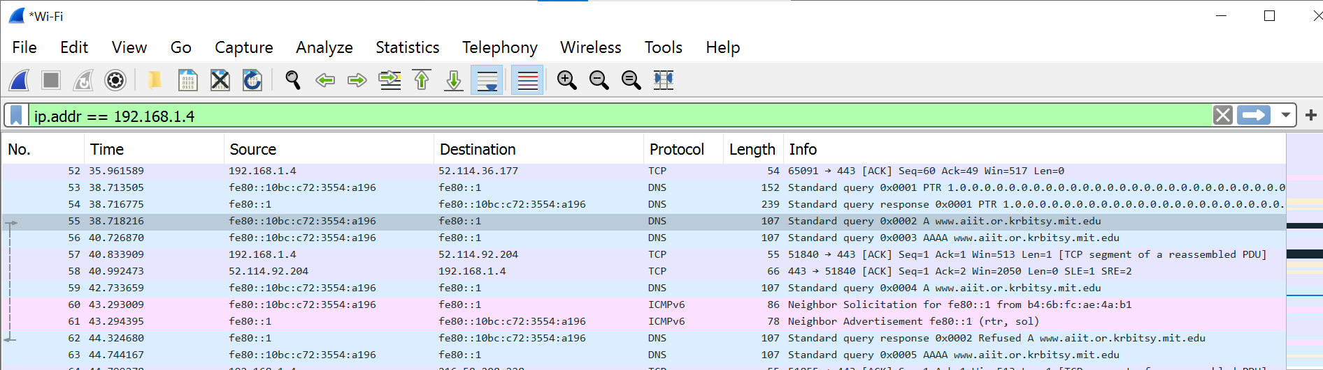

1. To what IP address is the DNS query message sent? Is this the IP address of your default local DNS server? If not, what does the IP address correspond to?

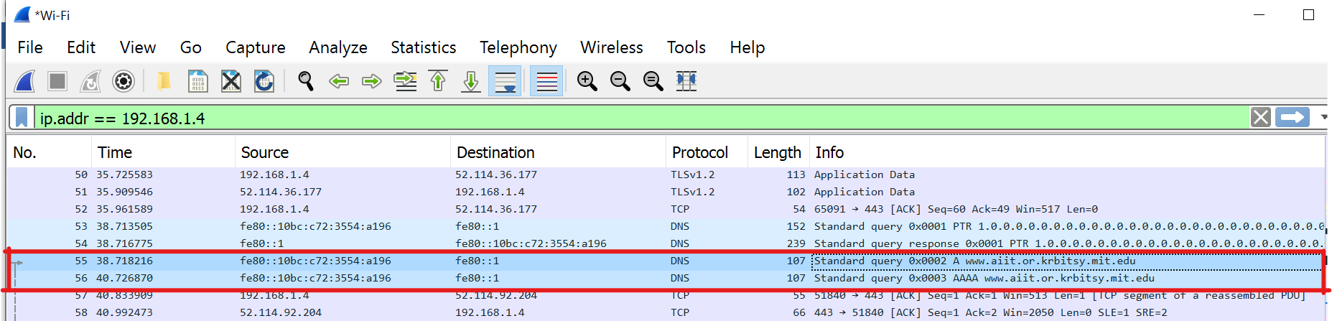

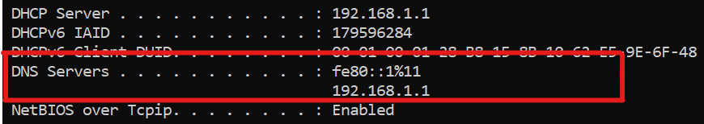

The DNS query message is sent to IP address fe80::1 (192.168.1.1), the same address as default local DNS server.

1. 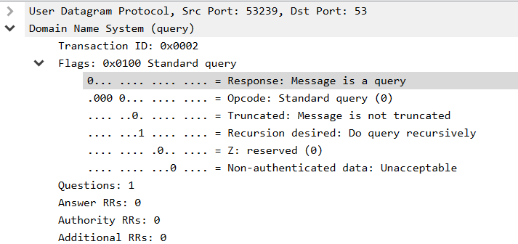Examine the DNS query message. What “Type” of DNS query is it? Does the query message contain any “answers”?

The DNS query message is a type “A” query, containing only one question and does not contain any answers.

1. Examine the DNS response message. How many “answers” are provided? What does each of these answers contain?

The response message contains one answer to the aforementioned query which is the type “A” address of <http://www.aiit.or.krbitsy.mit.edu>.

